The Backbone Architecture Description Language

Extending a core architecture using component redefinition primitives


Table of Contents

1. Introduction 3
2. The Backbone Language 4
2.1. Metamodel 4
2.2. Overview 4
2.3. Architectural Integrity 6
2.4. Redefinition Primitives 7
3. Example 9
3.1. The Core System 9
3.2. Extending the Core Architecture 12
3.3. Summary 15
4. The jUMbLe Case Tool 16
5. Future Directions 17
Bibliography 18

Introduction
Backbone is an architecture description language (ADL) allowing the architecture of a system to be specified in terms of components and connections between those components. The Backbone model allows components to be recursively defined much in the same way as in the Darwin and Koala ADLs [Darwin].
The main differentiating features of Backbone are:
- The component metamodel is aligned to the UML2 composite structure metamodel
The metamodel is specified in terms of components (structured classes), ports, parts and connectors.
- Redefinition facilities are provided, allowing modifications to existing components
A comprehensive set of redefinition primitives is available, allowing “surgery” to be performed on components. Component redefinitions are structured as additional artefacts, which “operate” on the existing component definition. A component redefinition can either create a new component in its own right, or can modify an existing component.
A Backbone definition binds together multiple layers to express the architecture of a system separately from the implementation artefacts. At runtime, the Backbone interpreter analyses the definition and instantiates and connects the implementation objects accordingly. Only the leaf components in the recursive hierarchy need to be implemented, currently using Java.
The redefinition facilities provide an ideal model for expressing “deep extension” architectures. Conventionally, systems designed for extension specify a number of extension points (plugin points) that are explicitly designed into the system. This report refers to this as a “shallow extension” architecture: the nature of the extensions have to be designed in advance.
This report presents Backbone as an alternative to shallow extension architectures, allowing deep extension of a core system. The underlying premise can be broken down into three points:
- Extensions to a system usually require extension points which cannot always be planned for in advance
- The best way to deal with this is to express the core system, and the extensions to the system, using the same architecture description primitives
- Extensions to a system require the ability to redefine arbitrary components from the core system
The Backbone redefinition primitives allow redefinition of a component without modifying the original Backbone component definition. The redefinition primitives allow surgery to be performed on a component model.
This report examines the Backbone language in more detail. A basic example is presented, illustrating a number of extension patterns.
The last section of this report explores how the jUMbLe UML case tool can be used to manipulate and extend its own Backbone architecture. The jUMbLe Backbone definition can be generated from a set of composite structure diagrams held in a jUMbLe model.

The Backbone Language

Metamodel
The metamodel used for Backbone is a simplified UML2 metamodel. Components are the primary structuring mechanism, and are composed of parts which are instances of other components. Components have properties, which represent configuration parameters.
Components interact with their environment exclusively via ports. Ports indicate the services offered by a component through a set of “provided” interfaces, and indicate the required services through a set of “required” interfaces. Connectors connect port instances (connector ends) together, providing the wiring to join provided and required interfaces together. Architectural artefacts are grouped into layers, which express explicit dependencies to other layers.
Figure 1: The Backbone Metamodel
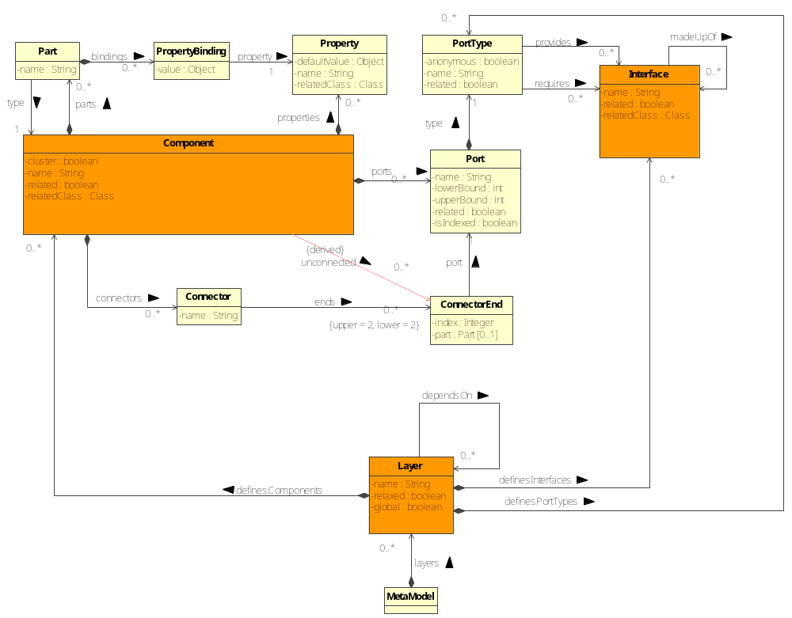
Figure 1: The Backbone metamodel

Overview
Backbone artefacts are grouped into layers, and layers must indicate their explicit dependency on other layers. The definition of a layer is specified in a “.definition” file. An example definition of a layer is:
layer toplevel
depends-on house, prettyhouse;
If a layer is marked as global, all other layers may access it without indicating an explicit dependency. Layers may also be marked as “is-relaxed”, in which case layers that depend upon it are also able to transitively see the layers it depends upon.
A full Backbone definition specifies which layers to load, in a “.combine” file. These must be specified in dependency order – no cyclic dependencies are allowed. An example combination file is:
toplevel
prettyhouse
house
backbone
Graphically, a layer is modelled as a package with a <<layer>> stereotype. A layer is intended to model a layer in a software stack, and has a coarser level of granularity than a standard package [Patterns]. A layer diagram shows the dependencies of the layers on each other, and gives an indication of the level of abstraction:
toplevel

prettyhouse

house

<<global>>
backbone

Layer diagrams cannot express complex architectures with many layer dependencies. Package diagrams are more flexible in this regard, although not as visually appealing.
Backbone supports composite interfaces, which represent a logical composition of interfaces as in the Darwin ADL. The composition facility is somewhat redundant given the provision of ports, which can support both required and provided interfaces. If an asterisk precedes an interface name, then it represents an implementation interface, and the back end will look for a Java interface with the same name:
composite-interface *IDisplayable
{
}
A component may define properties, which represent configuration values. Ports, parts and connectors can also be defined:
component House
{
properties:
String name(“My house”);
ports:
display provides IDisplayable, IMessageBoard;
parts:
HouseDisplay houseDisplay
set name(name);
connections:
displayConnector joins display to display@houseDisplay;
}
Note that all constituent items of a component are explicitly named. Naming all elements is a vital aspect of the redefinition mechanism.
If an asterisk precedes the name of a component, then this represents an implementation component. In the following example, the Java back end will look for a class called HouseDisplay:
component *HouseDisplay
{
property:
String name;
ports:
display provides IDisplayable, IMessageBoard;
}
Implementation components may define properties and ports, corresponding to Java level attributes and methods. Parts and connectors may not be defined for this type of component.
A component may declare that it is like another component. In the following example, the component TestHouse “inherits” all structural features of House, and defines a further property:
component TestHouse
is-like house.House
{
properties:
Color background;
}
The House component reference must explicitly qualify the layer if the inheriting component is not in the same layer. Note that “is-like” only implies type conformance if the inheriting component does not remove or render any of the ports incompatible through redefinition.

Architectural Integrity
The architectural integrity of a Backbone definition relies (in part) on verifying that no component references or port interfaces are indirectly acquired in a way that cannot be tracked by the Backbone language. The most common way to pass these references is to send them via method parameters, from one component to another. If this is allowed, then components may be dynamically and surreptitiously connected to other components without these connections being expressed in the Backbone definition. The definition is then no longer the sole source of connection information, and becomes less valuable.
To record, or ideally prevent this situation, Backbone provides two features:
- Explicit support for component clusters
A component “cluster” passes specified interface references via parameters in method calls via one or more of its ports. There are sometimes valid reasons for this, but it is important to be able to track these cases at an architectural level. All exposed interfaces must be declared in the cluster component definition.
- Low level checking of implementation interfaces
Backbone checks that the interfaces used by the port interfaces of a component are consistent with the exposed interfaces in the component definition. If the component is not declared as a cluster, then no Backbone interfaces may be passed as a method parameter. This is a sanity check that can be bypassed by upcasting any parameter before sending and downcasting on reception, but is useful in preventing inadvertent passing of connection information.
An example of a cluster component that exposes two specific interfaces is:
component A
is-cluster
{
exposes:
InterfaceA;
InterfaceB;
…

Redefinition Primitives
It is possible to redefine an existing component, through deletion, addition or redefinition of its constituent items. Backbone guarantees that all redefinitions are processed before the component definition is used elsewhere, including “is-like” usages. The processing engine copes with the complex, potentially recursive relationships that can be established due to “is-like” and redefinition relationships.
The redefinition of a component must occur in a different layer to the one that the original component is defined in:
redefine-component house.House
{
redefine-properties:
String name(“Redefined house”);
}
It is possible to redefine properties, ports, parts and connectors. The processing order is deletions, additions and then redefinitions (which are implemented as logical deletion followed by addition).
If a component is redefined, then any component that “is-like” this one will also implicitly be redefined. This is possible through the use of names to refer to constituent items of a component.
The redefinition primitives support a number of patterns, such as the delegation, decorator and adapter patterns [Gang of Four]. See the example following this section for a more extensive example of redefinition.
Redefinition provides a precise way for extension developers to customise any component in a core system. Large components can be tailored extensively if required, allowing for a greater level of reuse than if redefinition facilities were not offered.
It is also possible to use redefinition to define a new component that “is-like” a source component. Deep changes can be made to the inherited structural elements, potentially rendering the inheriting component no longer type conformant. This is achieved without affecting the original definition of the source component in any way.
Redefinition is enabled by the fact that every constituent item in a component definition must be given a name. The redefined item is not constrained to having the same type or structure as the original item. Any architectural inconsistencies introduced will be picked up in the Backbone checking phase. For instance, the type of a property can be redefined from a “String” to an “Integer”, as long as this is compatible with the rest of the system.
Consider the following component definition:
component A
{
properties:
String name(“jUMbLe”);
Integer index;
Ports:
basic provides Itest;
Parts:
B b
set age(100),
height(1.2);
connections:
wire1 joins basic to port@b;
}
Another layer can redefine this component extensively:
redefine-component layer.A
{
properties:
String company; // added new property
redefine-properties:
String name(“unknown”); // changed default value
Double index; // changed property type
redefine-ports:
basic provides ITest, ITest2; // added an interface
redefine-parts:
C b // upgraded b to C, a type-conformant
// sub-type of B
set age(120),
height(1.3),
name(“C”); // overrode a default value
redefine-connections:
wire1 joins basic to port2@b; // redirected a connection
// (note: b is now type C)
}
Any introduced features that are incompatible with the rest of the architecture will be statically detected during the Backbone checking phase.
It is generally possible to structure a redefinition of a component so that it is able to coexist with other redefinitions of the same component, or have the incompatibility statically detected. Further work in this area will make this simpler to achieve (see section 6).

Example
The following section demonstrates how Backbone can be used to customise a simple example system.

The Core System
The layering of the core system consists of the following packages:
Figure 2: Layers of the core system for the example
The House layer defines a simple House, which is capable of rendering itself as a graphical widget on a display. It also provides a message board, which displays messages for the house:
The HouseDisplay component is implemented in Java, as are the two interfaces. The House component is solely a Backbone construct.
The Backbone definition for the above diagram is:
composite-interface *IDisplayable
{
}
composite-interface *IMessageBoard
{
}
component House
{
ports:
display provides IDisplayable, IMessageBoard;
parts:
HouseDisplay houseDisplay;
connections:
displayConnector joins display to display@houseDisplay;
}
component *HouseDisplay
{
ports:
display provides IDisplayable, IMessageBoard;
}
The displayConnector delegates from the House’s port to the port of the internal HouseDisplay part.
PrettyHouse defines a variant of House that “is-like” House, but redefines the houseDisplay part to draw an image rather than a line drawing of a house:

The use of the <<redefined>> stereotype indicates a core feature of Backbone: it has a precise graphical representation for each construct. This is a vital aspect of the language in order to allow a case tool to represent a complete Backbone definition.
The Backbone definition for PrettyHouse is:
component PrettyHouse
is-like house.House
{
properties:
String imageName("resources/house.jpg");
redefine-parts:
PrettyHouseDisplay houseDisplay
set imageName(imageName);
}
component *PrettyHouseDisplay
{
properties:
String imageName;
ports:
display provides house.IDisplayable, house.IMessageBoard;
}
The “houseDisplay” part has been redefined, and replaced with an instance of PrettyHouseDisplay, which is a Java implementation component. The displayConnector will be “inherited” from House and form a delegation connector from the display port of PrettyHouse to the display port instance of houseDisplay. This is an implicit redefinition of displayConnector.
Finally, a top level component ties a House and a PrettyHouse instance together into an application:
Running the Backbone definition through the interpreter shows the following screen:
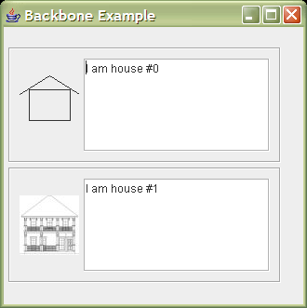
Note that the houseDisplay for House shows a line drawing of a house, followed by the message board widget. The houseDisplay for PrettyHouse shows an image of a house, followed by its message board.

Extending the Core Architecture
The following section shows how to extend the core system. In this case, the example will add an alarm widget to each house, demonstrating a redefinition of the House component. The redefinition will also affect PrettyHouse, because it “is-like” House.
The RedefinedHouse layer redefines the House layer by adding elements of the Alarm layer into the existing components:
The Alarm layer defines a BasicAlarm component, which displays an image and a button. When the button is clicked, the IAlarmable “alarmTriggered()” method is invoked with a message. Note that Alarm is a separate component, with no explicit dependencies on the core system (apart from an incidental dependency on IDisplayable).
The RedefinedHouse layer customises the House component, introducing the alarm part:

This entire component is a redefinition of House, as shown by the “<<redefined>>” stereotype.
The AlarmedHouseAdapter component serves to adapt between the IMessageBoard interface provided by the HouseDisplay, and the IAlarmable interface required by the BasicAlarm. When the alarm is triggered, the adapter writes a message to the board. This is a use of the Adapter pattern [Gang of Four].
The DisplayMultiplexer demonstrates the multiplexer and delegation patterns. We want to replace a single display component (HouseDisplay) with two (HouseDisplay and BasicAlarm). The multiplexer turns a single IDisplayable interface into multiple, allowing both components to display. It delegates to the HouseDisplay and BasicAlarm to perform the actual display tasks. This is a use of the Delegator pattern.
The Backbone definition for the redefined House component is:
redefine-component house.House
{
parts:
DisplayMultiplexer multiplexer;
AlarmedHouseAdapter adapter;
alarm.Alarm alarm;
delete-connections:
displayConnector;
connections:
mainConnector joins display to display@multiplexer;
displayConnector joins displays[1]@multiplexer to
display@houseDisplay;
displayConnector2 joins displays[0]@multiplexer to
display@alarm;
alarmConnector1 joins alarmClient@alarm to
alarmClient@adapter;
alarmConnector2 joins board@adapter to
display@houseDisplay;
boardConnector joins display to display@houseDisplay;
}
component *DisplayMultiplexer
{
ports:
display provides house.IDisplayable;
displays[0..*] requires house.IDisplayable;
}
component *AlarmedHouseAdapter
{
ports:
alarmClient provides alarm.IAlarmable;
board requires house.IMessageBoard;
}
Note that ports can have cardinality.
To run the example, we need to introduced the layer via a modified “.combine” file:
redefinedhouse
toplevel
prettyhouse
alarm
house
backbone
The difference from the core “.combine” file is simply the inclusion of the redefinedhouse layer. No code or Backbone definitions from the core system have been modified.
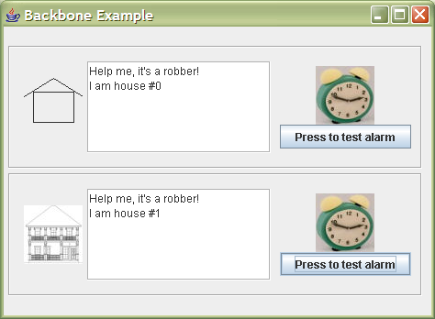
Running the redefinehouse example shows that the alarm widget has been added to both House and PrettyHouse:

Rather than redefine the base House component, it is possible to modify only the PrettyHouse component, via a slight change of redefinedhouse:
redefine-component prettyhouse.PrettyHouse
{
parts:
DisplayMultiplexer multiplexer;
…
Running this example gives the expected result that House is unmodified, but PrettyHouse has an alarm:

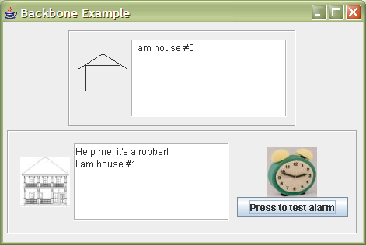

Summary
The example above uses Backbone to extend a core system in an unintrusive and relatively unanticipated way. Although simple, it demonstrates the following features:
- The principled modification of an existing component through the insertion of new parts and redefinition of old parts
- The use of the same architecture definition facilities for core and extension development
- The use of architectural patterns to support the redefinition
- The UML2 graphical depiction of a Backbone definition
The extensions were made to the core system without any modification of the core Java or Backbone files. The entire extension was defined as an addition to the core, even though it fundamentally altered the facilities of some of the core components.

The jUMbLe Case Tool
jUMbLe is a UML2 case tool, whose entire architecture is expressed as a Backbone definition. Since a Backbone definition can be fully represented as a set of composite structure diagrams, the architecture of jUMbLe can be exist as a UML model inside the case tool itself. Further, jUMbLe is able to generate the full Backbone definition directly from the composite structure diagrams.
The application is obvious: jUMbLe is able to manipulate and define its own architecture. In addition, extensions to the tool can be depicted as component redefinition diagrams, allowing deep modifications to the core of the tool, without compromising the core architecture.

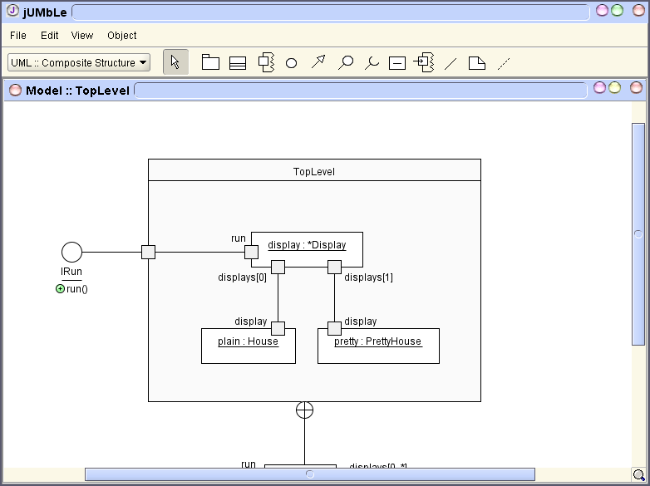
Backbone
interpreter
Backbone architecture definition of jUMbLe
Automatically
generated
jUMbLe architecture expressed as composite structure diagrams, in jUMbLe
Run-time interpretation

With this graphical approach, it is not necessary to directly write textual Backbone definitions. The text is generated automatically from the composite structure diagrams. Since a crucial aspect of the Backbone language is the ability to express modifications to a set of components as additional artefacts, rather than through direct modification of the core artefacts, it is important that the jUMbLe model repository also support this feature. The repository allows extensions to a model to be ”layered” on top of this model, and does not tie the original model to the extension model.
Backbone also supports the specification of simple distributed architectures. jUMbLe has the ability to operate in a three-tier configuration, where multiple clients connect to a single server in the middle tier, allowing multiple users to collaborate on the same model. The Backbone specification of this architecture is achieved by defining selected components and interfaces to be compatible with the Java RMI model. A naming component is registered with the Java RMI registry, and from this all other required components can be found. Backbone connectors do not explicitly support the remote model, but rely on the Java RMI infrastructure to make the remote components appear to be local, via a proxy.

Future Directions
Work on Backbone is continuing in several directions, primarily in order to support some of the advanced features of the jUMbLe architecture. Of particular interest are dynamic connection facilities and the ability of Java programs to dynamically instantiate Backbone components in a way that can be captured in the Backbone definition.
Other directions of interest are:
- Proxy based aspect oriented support
Spring [Spring framework] and other systems have demonstrated the feasibility and usefulness of proxy based aspects. The Backbone model is a good match for this approach. Aspect oriented facilities could be used to provide support for graphical debugging, relaying the contents of each communication message to a graphical debugging tool which shows the information on a UML diagram.
- State machines
Currently, Backbone only addresses the structural aspect of architecture. Much of the jUMbLe dynamic architecture is expressed as state machines. The logical next step is to specify these state machines an extended form of Backbone. Using the proxy based aspect features, graphical visualisation of state machines could be supported.
- Versioning
Support for tagging ports, interfaces and components with version information is planned. This will provide a facility to automatically check if an extension is compatible with a newer version of the core architecture.
- Design by contract
The Backbone component model may be extended to support design by contract. OCL is the obvious candidate for a constraint language. A subset of OCL would be fused into the Backbone language, allowing developers to more fully specify the contract side of a component.
- Product lines
The approach outlined in this paper has its background in research for supporting the architecture of a product line or family. To support this approach more fully, Backbone will add a generic type facility as supported by the Darwin ADL. This facility will be provided by making component types first class, and allowing types to be held as the value of a property.
- Support for the coexistence of multiple extensions of the same core architecture
It is common for an application to require the use of multiple extensions, which must coexist, even though they have been developed independently. Backbone provides a level of support for this via redefinition of logical names, but further facilities are required to make this simpler and more transparent. For example, two separate extensions may redefine the same component, and support is needed to make sure that these extensions will be compatible.
This is a problem that plagues conventional extension architectures. A user will purchase a core product, and then want to use two different products that build on that architecture, but which have not been tested together and are incompatible in practice.

Bibliography

[Darwin]
Magee, Dulay, Eisenbach and Kramer. Specifying Distributed Software Architectures. Proceedings Of the 5th European Software Engineering Conference, LNCS 989. Springer-Verlag, 1995.

[Patterns]
Buschmann, Meunier, Rohnert, Sommerlad and Stal. Pattern-Oriented Software Architecture (A System of Patterns). Wiley, 1996.

[Gang of Four]
Gamma, Helm, Johnson and Vlissides. Design Patterns. Addison-Wesley, 1995.

[Spring framework]
Johnson et al. The Spring Framework. http://www.springframework.org

Work in progress, 23rd February 2005

